Name: Chika Lilian Onyagu

Course Path: Data Analysis

Admin ID: DG/C23/11348

**Question1: Display the customer names that share the same address**

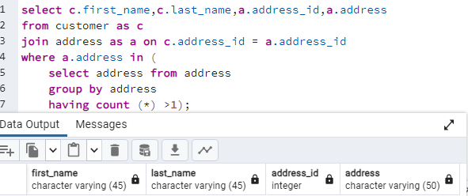

Question 2: the name of the customer with the highest total payment.

Question 3: What is the movie that was rented the most

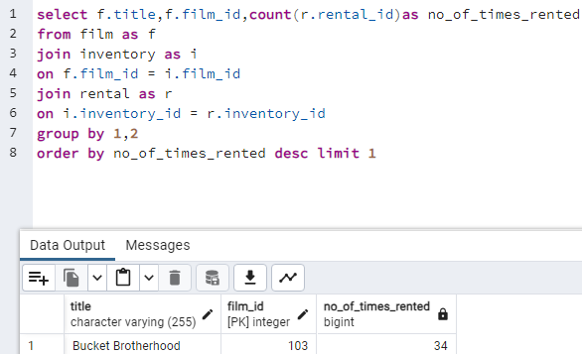

Question 4: which movie have been rented so far

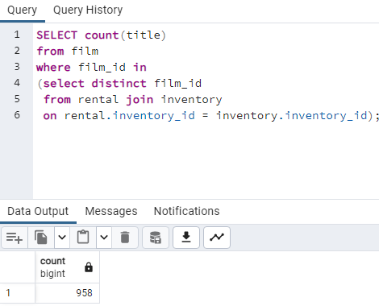

Question 5: which movie have not been rented so far

Question 6: which customer have not rented any movie so far

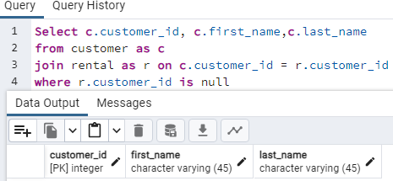

Question 7: display each movie and the number of times it got rented

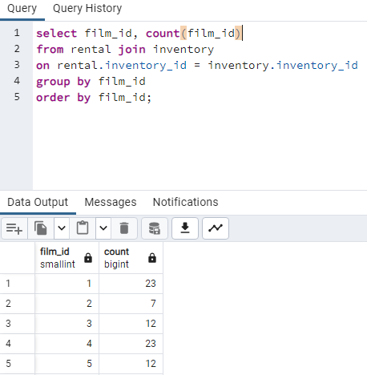

Question 8: show the first name and last name and the number of films an actor acted in.

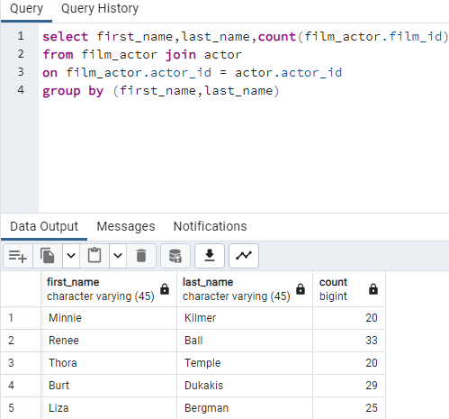

Question 9: Display the names of the actor that acted in more than 20 movies

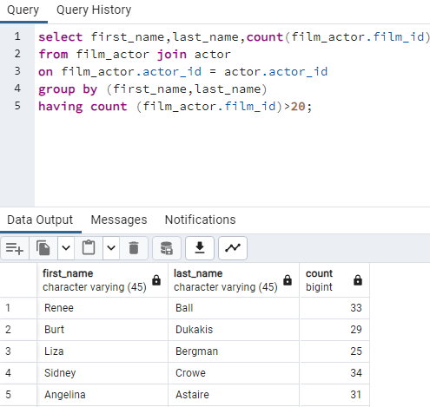

Question 10: For all the movies that rated “PG” show me the movies and the number of times it got rented

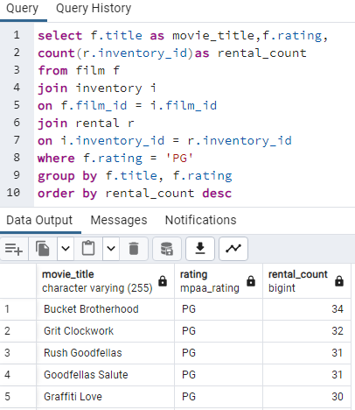

Question 11: Display the movies offered for rent in store_id1 and not offered in store_id2

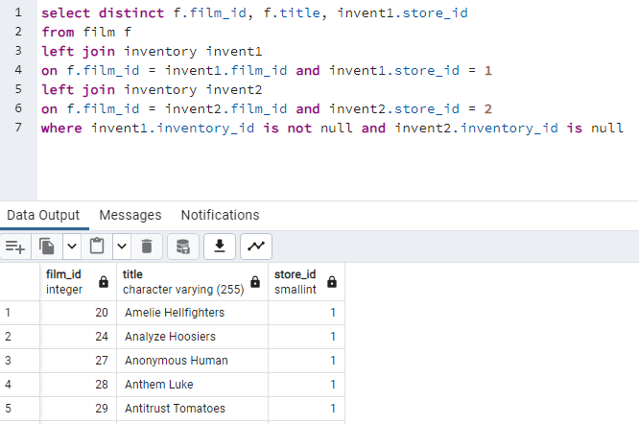

Question 12: Display the movies offered for in any of the two stores 1 and 2

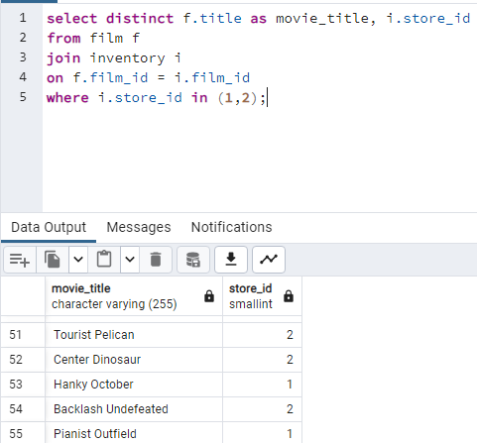

Question 13: Display the movies offered of those movies offered for in both stores at the same time

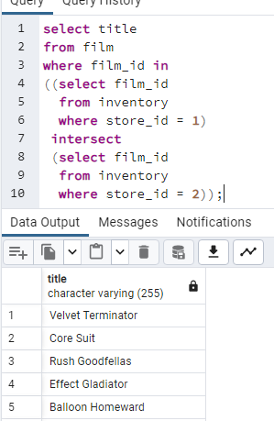

Question 14: Display the movies the movie title for the most rented movie in the store with store id1.

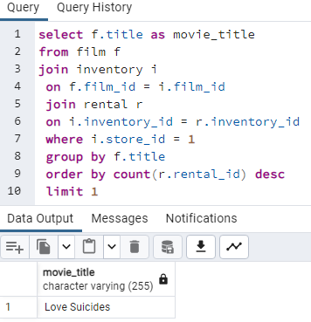

Question 15: How many movies are not offered for rent in the store yet there are two stores 1 and 2

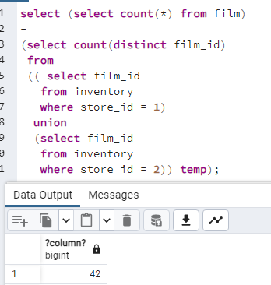

**Question 16: Show the number of rented movies under each rating**

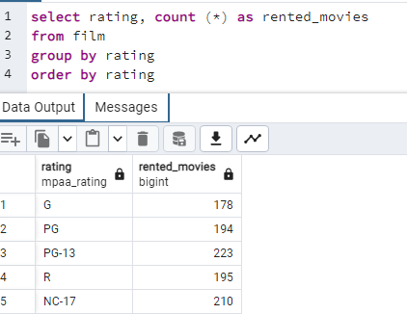

Question 17: Show the profit of each store 1 and 2

